INSTALLATION INSTRUCTIONS

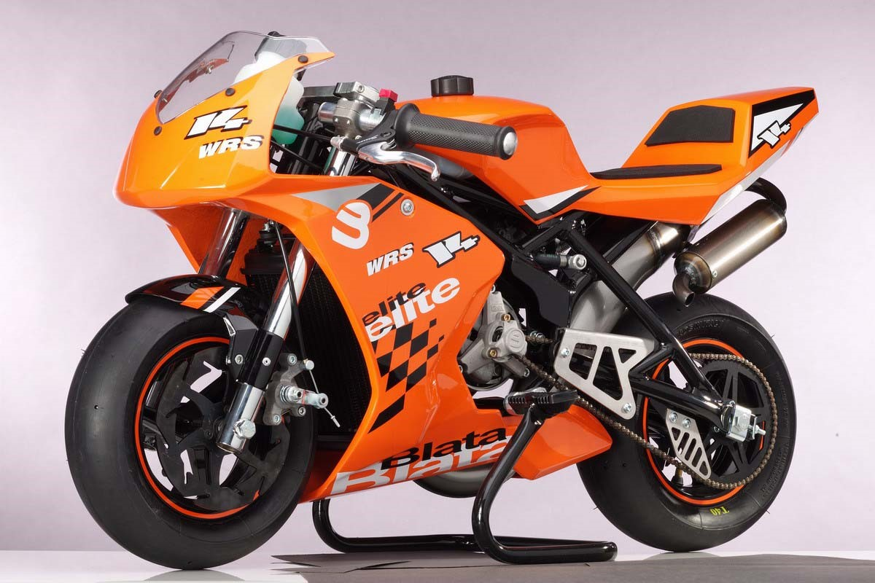

KIT BRAKE WITH 2 FLOATING DISCS

The E2KIT BRAKE mounting kit with 2 floating discs is designed for ELITE minibikes: E 14 R; E 14 J racing and E 14 WRS

335.010.50 | FORK LEFT KIT | 1
335.012.50 | FORK RIGHT KIT | 1
332.045.00 | BRAKE DISC - LEFT | 2
332.046.00 | BRAKE DISC - RIGHT | 0
332.061.00 | CABLE WITH ADAPTER | 1
342.031.00 | FRONT BRAKE LEFT - KIT | 1
342.032.00 | FRONT BRAKE RIGHT - KIT | 1
342.021.00 | GUIDE ROLLER | 4
914.001.01 | SCREW M5 x 16 | 4
313.020.33 | WHEEL COMPLETE WITHOUT TIRES 2.1 "x 6.5" - 99 (6 x thread M5)

- Installation instructions:
- - remove the front fairing and fender (drill the fender rivets)

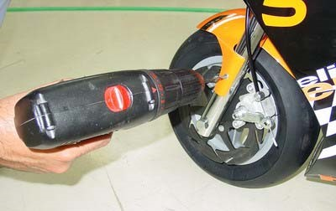
- Loosen the brake cable catch and remove the cable
- unscrew the screw 312.018.00 and remove the brake pads and spring out of the brake caliper
- Loosen and pull out the front wheel axle. Pull the wheel out of the brake caliper in the direction of the forks
- Loosen the M6x20 bolts of the left handlebar sleeve and the M5x35 bolts in the upper and lower left fork brackets. Slide out the fork and insert the left kit fork into the holders. Slightly tighten the bolts in the fork holders so that the fork can rotate as the wheel settles. Tighten the handlebar sleeve bolts lightly. Do the same when replacing the right fork.
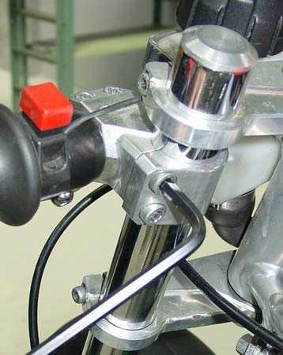
- Screw the floating discs onto the wheel kit disc (tightening torque 15 Nm) CAUTION - do not confuse the right and left discs during assembly!

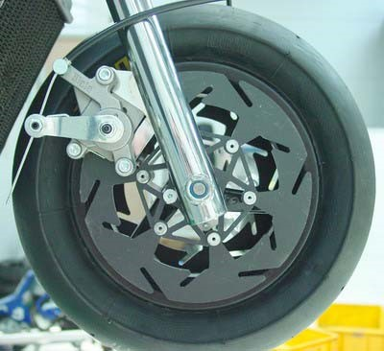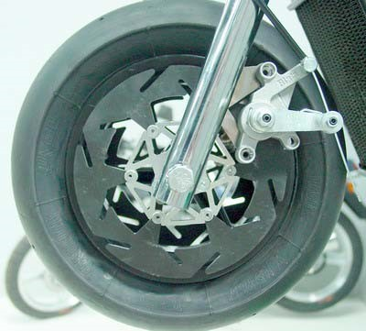

pravý
levý
- place the wheel on the fork - when inserting the wheel axle, insert spacers (L = 7mm) between the forks and the wheel disc. Tighten the wheel axle properly (tightening torque 35 Nm)

- tighten the M5x35 bolts in the fork holders (tightening torque 9 Nm) and the M6x20 bolts of the handlebar sleeves (tightening torque 15 Nm)

- Remove the brake pads and spring from the right kit brake caliper. Place the caliper on the brake disc and slide it onto the brake bracket on the fork (make sure that the brake pin 312.038.00 does not fall out of the caliper during installation!). Screw the M5x16 screws with guide rollers onto the holder. Secure the connection with thread adhesive and tighten to 9.5 Nm. Do the same when installing the left kit brake

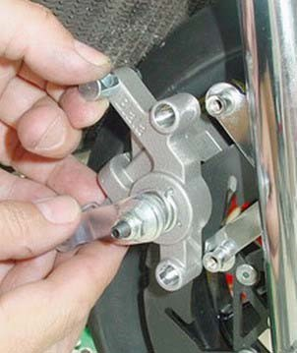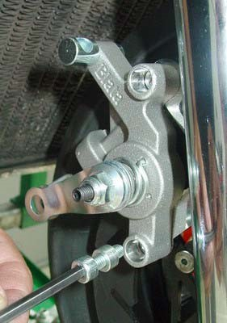

- Fit the brake pads and springs in the brake calipers. Secure them with screw 321.018.00

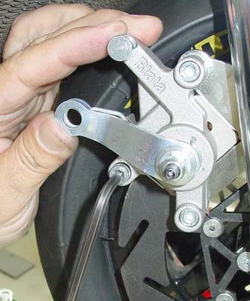
- Fit a new brake cable with adapter. Follow these steps:
1, insert the cable roller with the adapter into the right brake lever. Install the adjusting screw as far as it will go.

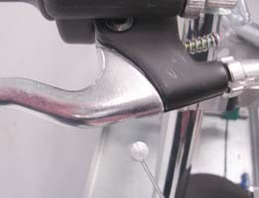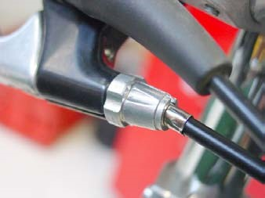

2, insert the cable catch into the lever on the brake caliper, through which the cable end is threaded (the shorter cable is threaded into the cable catch on the left brake caliper, the longer cable on the right)

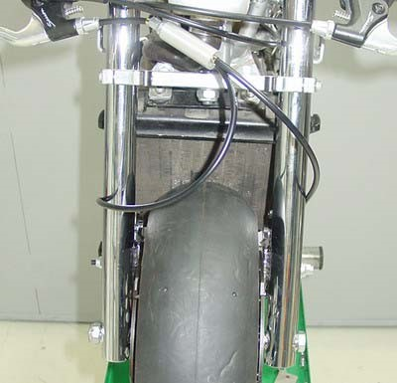

3, turn the cable catch lever to define the clearance between the cam and the brake pad (the wheel must rotate freely). Secure the cable by tightening the cable retaining screw

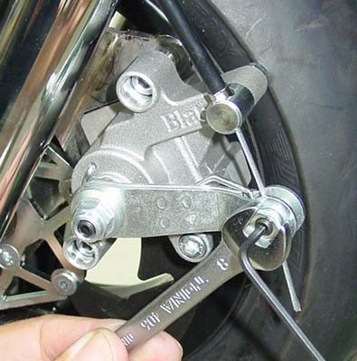

4, adjust the brakes according to the instructions (chapter basic brake adjustment). Make sure that the brakes apply evenly. When braking slightly, check that the clearance on both caliper levers is the same.

